Carbon Reduction Policy Statement
Our carbon footprint policy statement is the stated policy of Intervention Services Ltd (ISL) to reduce its environmental impact where practicable. Carbon reducing measures form an integral part of the overall companies strategy, helping us to improve both operational performance and a reduction in potentially harmful emissions to land, water, and air.
The Company’s ultimate aim is for a 0% carbon balance to be achieved within a period ending January 2032, or before where practical.
Objectives To help achieve this, ISL will:
• with all current energy legislation, seeking to meet or better legislative targets.
• Minimise waste, promote recycling and the use of recycled products to help reduce the burden on landfill, and corresponding methane generation.
• Continue to promote and support the objectives of the policy.
• Promote environmental awareness and responsibility amongst employees and others, and seek where practicable to continuously improve ISL environmental performance.
• Actively promote telephone conferencing as a means of reducing travel requirements.
• Evaluate the potential benefits of home-working.
• Evaluate the potential Comply benefits of carbon off-setting.
• Continually review and develop the Group’s Occupational Driving Policy using Samsura.
Establish where we are now and address;
Scope 1 direct emissions; our fuel consumption & idling times, our tarmac suppliers and moving towards ‘warmer’ products. We measure our waste and ensure as much as possible is recycled.
Scope 2 indirect emissions from our utility providers whom provide our electric and gas. We have completely moved to LED lighting inside and outside and continue to review all aspects of our energy consumption
Scope 3 indirect emissions from our suppliers. These emissions are a consequence of our company’s business activities but occur from sources the company does not own or control. This is by far the largest area in which for us to concentrate.
Scope 3 emissions include the following: Emissions generated in the company’s supply chain, such as extraction, production, and transportation of purchased tarmac materials and fuels to site. Emissions generated from waste disposal. This includes the disposal of waste generated both in operations and in the production of purchased materials and fuels, as well as disposal of these products at the end of their life.

Actions currently being developed include:
• Integration of environmental issues into all aspects of the decision making processes.
• Sustainable sourcing procurement policies.
• Evaluation of energy efficient and correspondingly carbon reducing equipment, vehicles and plant throughout the company. Set reduction targets
• Promotion of the Transport’s manager ‘Smarter Driving Tips’ initiatives utilising Samsura.
• Vehicle sharing and mileage reduction planning.
• The assessment and procurement of fuel efficient vehicles, supported by effective delivery and field operations planning.
This Carbon Footprint Policy Statement underpins the existing Environmental, Procurement, Waste Management, Quality Assurance, Health & Safety, and Corporate Responsibility Policies already implemented throughout the company. This policy clearly identifies the responsibilities and procedures for achieving the Companie’s stated objectives in all aspects of our activities, leading to improved environmental performance, inclusive of reductions in both CO2 and methane emissions.
Carbon footprint policy
Intervention Services Limited recognises that our work may have a direct or indirect effect on the local and / or regional environment. We are therefore committed to reducing any harm that this may cause. Our carbon footprint – green policy is to constantly look for ways in which we can improve our green credentials, we are achieving this by holding regular meetings to explore ways to achieve our statement promises and to link with other likeminded organisations. Our carbon reduction strategy is aligned with our company environmental policy and company sustainability policy and current codes of practice on waste and environment protection.
We will focus on:
• Reducing waste,
• Reducing materials at every opportunity,
• Repair rather than throw away where we can
•Recycle at any given opportunity.
Action Plan, we aim to:
• Encourage our employees and suppliers to be responsible, corporate green citizens,
• Utilise energies and water sparingly,
• Consider environmental impacts in our purchasing,
• Endeavour to work with partnering organisations that share our ethos on “carbon footprint” eg, tarmac suppliers and warm asphalt initiative’s
• Reduce the need for transport and its impacts on the environment. Cut out wasted journeys
It is our intention to operate our business in an environmentally friendly and sustainable way as possible.
What we have already introduced:
• We reuse, or recycle, all of our packaging materials such as cardboard, polystyrene, shredded paper etc. All materials that can be recycled are segregated into specific waste bins / skips and forwarded to waste transfer stations.
• We minimise the use of paper in our offices through the use of email, this has greatly reduced the amount of paper used within the workplace, and previously we would have sent hard copy correspondence in the post. Processing information electronically is also much more energy and carbon efficient than physically sending hard copy correspondence.
• We have installed multi-function devices to handle faxing, printing and photocopying demands in our offices; this greatly helps reduce energy and also reduces paper usage. Eg, Officenet
• We supply internal recycle bins for our office paper.
• Our consumption of fuel and energy is closely monitored and we take care that it is not wasted through inefficiency.
For example all radiators have been fitted with Thermostatic Radiator Valves, we use signage to remind staff to turn off lights when leaving a room, and ask staff to use computers responsibly i.e turning them off at night and using standby mode during the daytime when not in use.
• We recycle old computers responsibly and will do so through our IT replacement strategy.
• We recycle mobile phones and printer cartridges.
• We recycle the fluorescent light tubes in our offices. Now LED.
• We have reduced the amount of our land fill waste by finding ways or recycling waste material more efficiently, either in house or through working in conjunction with others who are able to use the material in a constructive way.
• We ensure that all our work places either in our offices or out on site adhere to current environmental standards and energy conservation requirements.
What we intend to do for the future:
• We intend to purchase our electricity from suppliers who re-invest in renewable energy sources
• Where possible we will source our materials from suppliers who operate in an environmentally friendly manner and who are geologically local to us to reduce road traffic, road traffic costs and carbon emissions.
• We will choose vehicles with fuel efficiency and CO2 emissions in mind, when our current fleet of company vehicles are due for replacement. Fuel efficiency and mileage will be closely monitored with the help of tracker systems. Examples;
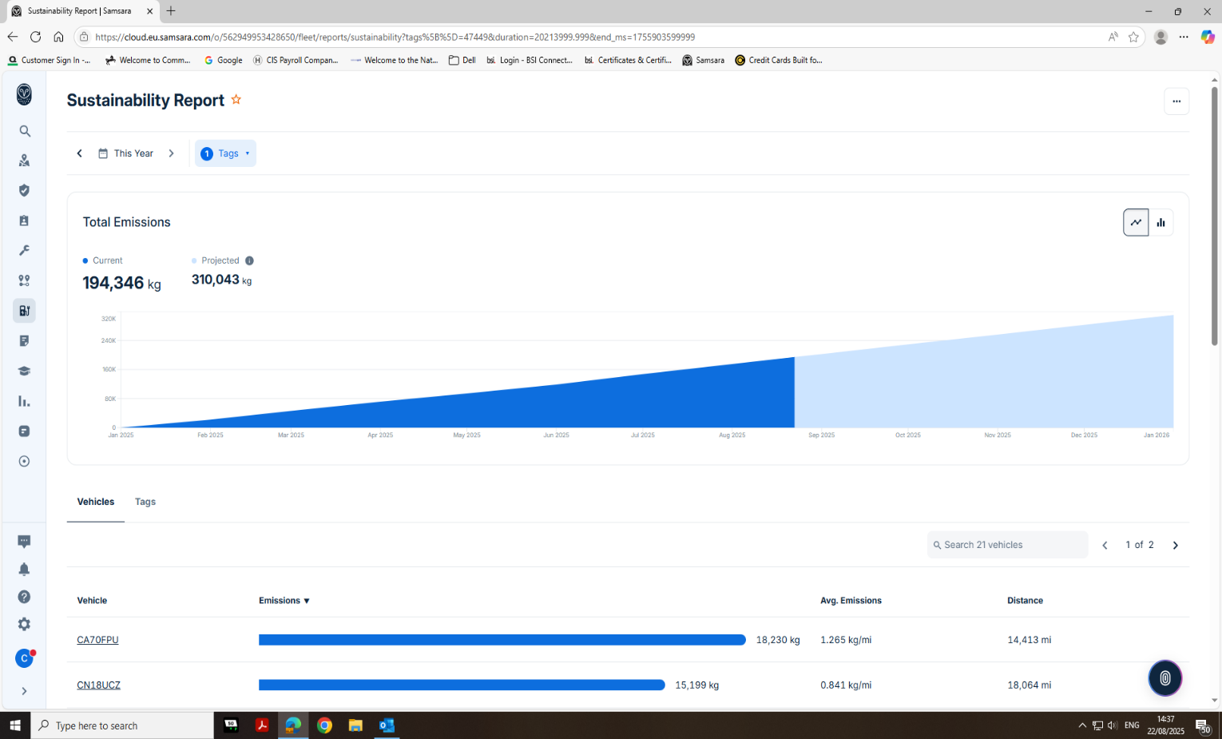

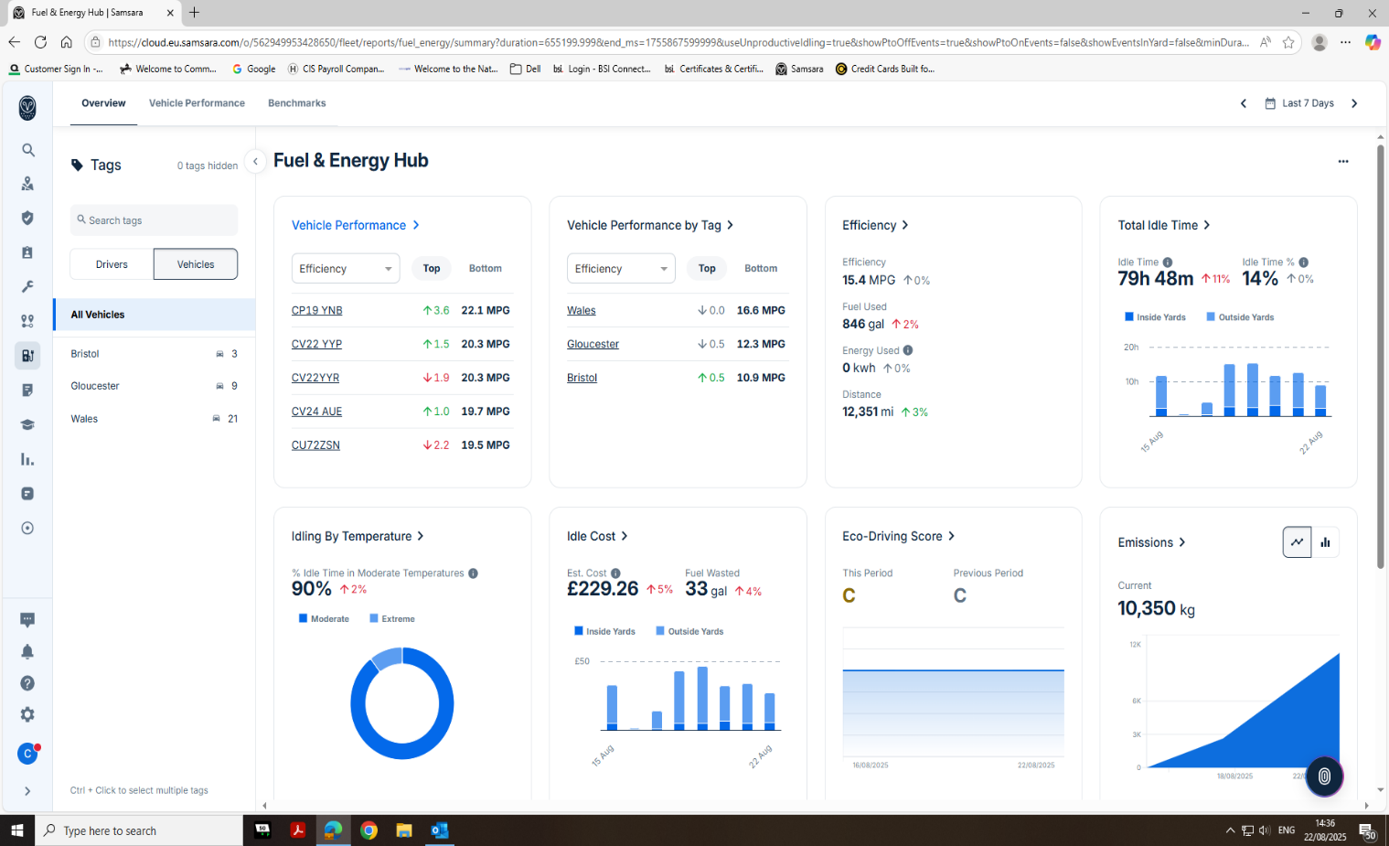
• We will encourage web links to sites promoting sensible and sustainable attitudes towards the environment, renewable energy etc.
• We will encourage suppliers to strive for the same level of environmental care as we provide to offset their carbon footprint.
• We will deliver awareness training on green issues and sustainable development to all employees in order to inspire them to reduce their carbon footprint and encourage them to take action to offset their carbon footprint in innovative ways.
• We will strive to reduce our carbon footprint year on year by measuring and calculating current standards in each of our offices.
• We intend to identify the size of the current Carbon Footprint in accordance with the latest DEFRA reporting guidance and the World Business Council's Greenhouse Gas Protocol.
• We will identify and quantify the sources of carbon emissions.
• We will identify carbon reduction initiatives. Immediate action is reducing ‘idling’ times on our fleet which will reduce emissions and save money.
• We will carry out ongoing measurement of the impact of reduction initiatives in order to aid company reporting of greenhouse gas emissions. ISL are reviewing a third party certification process such as Greendragon, to assist in developing our action plans further.
Intervention Services Limited will aim to reduce its carbon footprint by 20% by 2027 to be in line with current UK legislations and World business council greenhouse gas protocol. ISL will choose vehicles with fuel efficiency and CO2 emissions in mind, when our current fleet of company vehicles are due for replacement. Fuel efficiency and mileage will be closely monitored with the help of our tracker system Samsura, along with route planning for all journeys for fleet of vehicles.
This policy will be reviewed in April 2027 but will continually endeavour to improve our practices.
Signature of person responsible for policy:-
Mr. Mike Donohoe

Managing Director
01/04/2026

