

Intervention Services Limited

Health & Safety Handbook

CONTENTS

Introduction Page 3
Emergency Key Holders Page 4
Health & Safety Policy Statement Page 5
Drug & Alcohol Policy Page 6
Anti-Bribery Page 7
Anti-Slavery Page 8
Whistle Blowing Page 9
CSR Statement Page 10
First Aid Page 11
Fire Page 12
Accident/Incident Reporting Page 13
Hazardous Areas Page 13
Housekeeping Page 13
Risk Assessments Page 14
Personal Protective Equipment Page 16
Portable Equipment Page 17
Contractors Page 17
Visitors Page 17
Using Display Screen Equipment Page 18-19
Manual Handling Page 20
Working at Height Page 21
COSHH Page 22
HAVS Page 23
Environmental Awareness Page 24
Drivers Policy Page 25-30
Information and Where to find it Page 31
Return sheet Page 32

INTRODUCTION

Intervention Services Limited are a well-established medium size company in South Wales who are privately owned and work together with major contractors/Clients on projects in Wales such as term maintenance contracts and First Tier contractors to the Civil Engineering and Utility Sectors.
The business has grown significantly over time and has a workforce who are highly experienced and qualified delivering a high standard of workmanship to specification and on time.

OUR VISION
To be a sustainable and respected organisation working towards, Framework, Partnering and joint venture Alliances.

OUR MISSION
We are fully committed to Health and Safety and Quality throughout the company with continual improvements where necessary, investing in the training and development of our staff.

OUR VALUES
We are committed to exceeding our client’s expectations through pride, openness and trust, within a safe and healthy working environment.

EMERGENCY

For any emergency, incident or accident call;

01443 238188

Mike Donohoe 07977155919 Director
Jason Combes 07917601703 Operations Manager
Martin James 07879550563 Yard Coordinator
Gareth Spure 07917236993 Supervisor
Nick Bennion 07918 459495 Supervisor Central
Chris Smith 07918 455131 Supervisor Central
Paul James 07919676562 Supervisor
Tom Watkins 07985 663206 Plant & Transport
Claire Sales 07747445501 Office Manager

Key Holders;

All KEY STAFF HAVE KEYS TO THE BUILDING

Health & Safety Policy Statement

Intervention Services Limited recognises that it has a responsibility as an employer to ensure the “Health, Safety and Welfare” of all employees whilst at work and is committed to its duty to prevent injury and ill health. Additionally it is the responsibility of all persons who work for this Organisation (Directors, Managers, and Employees etc.) to ensure this policy extends to all other persons who may be affected by our work activities. In this way, each and every individual within Intervention Services Limited has a vital and specific role in maintaining Intervention Services Limited health and safety standard.
Responsibility for the overall implementation, maintenance and development of our safety management system, however, rests with the senior management, including the regular setting and reviewing of objectives, and the provision of adequate resources to allow those objectives to be achieved.
It is also the responsibility of senior management within Intervention Services Limited to ensure that our health and safety policy conforms to all applicable legislation.
Management recognise the importance of its staff and encourages the reporting of any hazard or risk that may adversely affect our health and safety standard. We also recognise the importance of ensuring that staff are adequately trained, informed and supervised to fulfil their activities in a safe manner.
Intervention Services Limited is committed to a management system that demonstrates a pro-active approach through the continual improvement of our health and safety performance. This is further achieved by the regular setting and reviewing of objectives to achieve compliance to current safety legislation applicable to our organisation, and through matching our industry’s best practices.
We as an organisation also recognise the need for the identification of hazards and the recording and reviewing of risk assessments.
The effectiveness of our health and safety policy and its implementation are subject to regular management reviews and all related processes and procedures are subject to an on-going audit schedule.

Mike Donohoe, MD

Intervention Services Limited Drug & Alcohol Policy

Summary

Intervention Services Limited is committed to providing a safe, healthy and productive working environment for all employees, contractors, customers and visitors involved in its operation. Intervention Services Limited also want to encourage and support employees who may have a Drug & Alcohol misuse and/or a Drug & Alcohol dependency problem by assisting them in seeking help and supporting them in overcoming Drug & Alcohol related problems.

Responsibilities

Managers have responsibility for monitoring health and safety in the workplace, and have responsibilities with regard to this policy and its enforcement. Managers should be aware of Intervention Services Limited rules and the implications of not tackling possible Drug & Alcohol misuse, especially where safety is an issue. All have a responsibility for their own health and safety in the workplace. Employees must take personal responsibility for their own Alcohol use.
All must report for work, and remain throughout the working day in a fit and safe condition to undertake their duties and ensure that Drugs or Alcohol never impairs their performance at work and their judgment. All must ensure that their consumption of Alcohol does not threaten the safe performance of their duties and that their behavior never puts themselves or others at risk. All must inform their immediate supervisor if they are taking any prescription drugs that may affect their normal working duties. This may include, but not exclusively; Pain killers, Anti-depressants, Tranquillisers, Anaesthetic/sedation following minor operation/dental work, Cold and flu remedies (e.g.Lemsip Max, Benylin or Beecham Flu Plus), Hay fever remedies and other anti-histamines
Alcohol may remain in an individual’s system for some time and even relatively small amounts can impair judgement, performance and jeopardise safety. All are personally responsible for allowing sufficient time for Alcohol to leave their system before reporting for work.
Drunkenness at work, or unauthorised drinking of Alcohol during working hours by all will be considered serious misconduct
All must not consume Alcohol at any time while at work, including during rest or meal breaks.

Any breach of the above rules will be treated as a serious breach of misconduct and may be treated as a disciplinary matter under the Company's formal disciplinary procedure

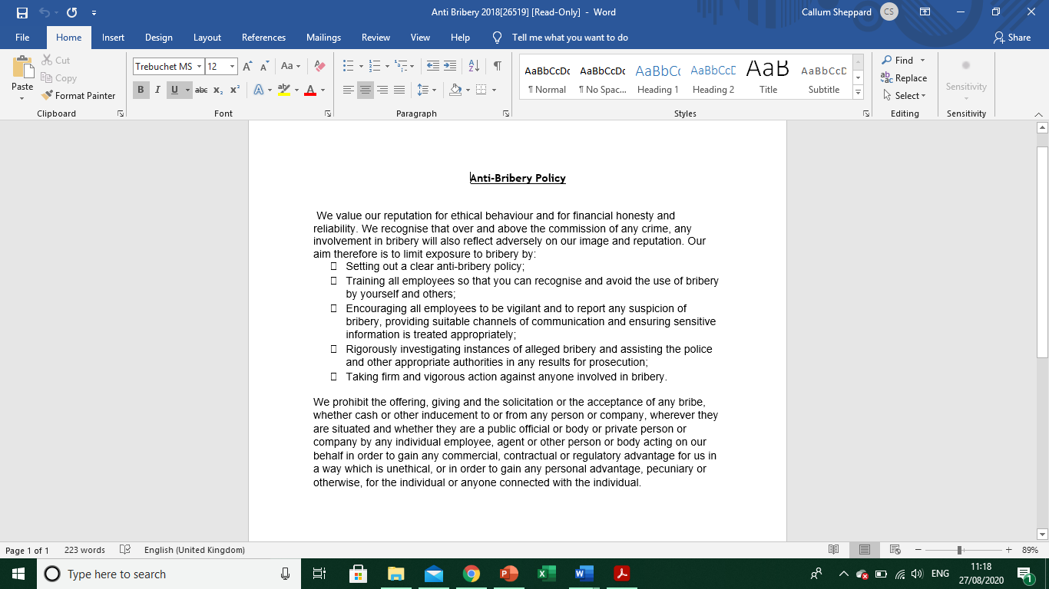

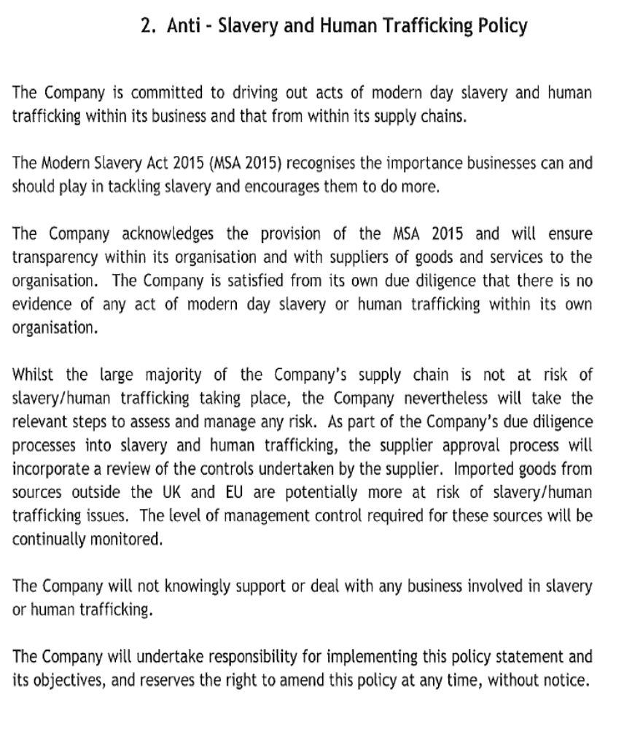

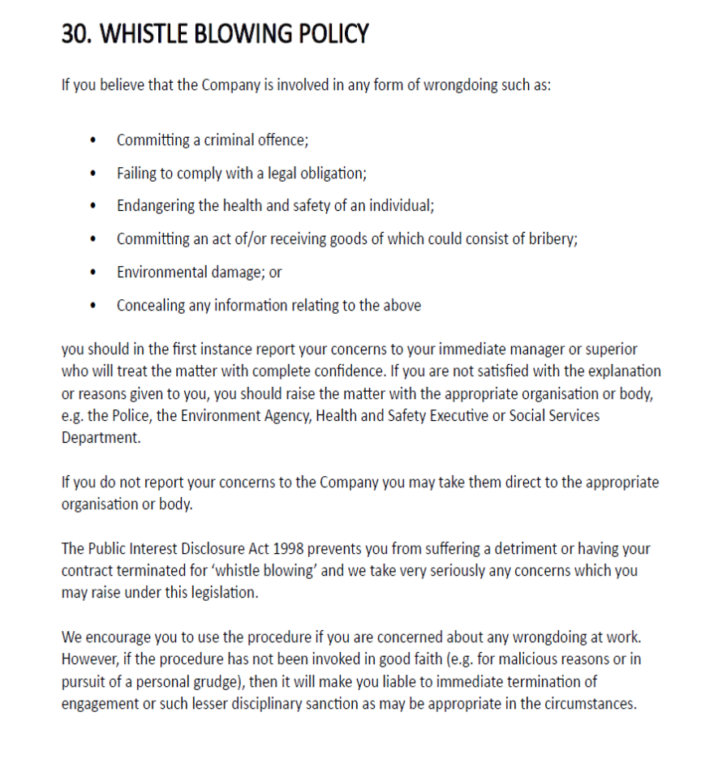

CSR statement

ISL want to be a responsible business that meets the highest standards of ethics and professionalism. We align to the Well-being of future generations (Wales) act 2015.
We are committed to:
• Compliance with all applicable laws, regulations and other employment standards. Our company will respect the law and ensure that all its business operations are legitimate. We’ll adopt corporate policies that benefit the environment.
• Respect the rights of every employee and treating them fairly and without discrimination.
• Promote a safe, healthy, inclusive and productive environment for all our people, whilst operating ethically. We will Recycle and Conserve energy wherever possible
• Encourage open, ethical, respectful and honest communications with all of our stakeholders
• Engage and motivate our people, providing the opportunity to learn through structured training programmes and development opportunities.
• Reduce our carbon footprint and environmental impacts wherever practical and to develop environmental policies
• Build positive relationships within the communities where we live and operate and reducing any negative impacts from our work operations.
• Support and generate economic and community benefits through charitable giving, our activities, workforce and supply chain. Carry out Volunteering in the community where possible.
• Understand and meet the needs and expectations of our customers providing them with sustainable solutions.
• Monitor and report on our progress in an open and honest way. Adopt Anti-bribery and anti-corruption practices
• Work with our suppliers and contractors to deliver our corporate responsibility commitment.
• Engage and seek dialogue with all our stakeholders to ensure we share the same values

.

FIRST AID

For minor first aid assistance, please contact your nearest First Aider.



STAFF WITHIN INTERVENTION SERVICES ARE EMERGENCY FIRST AID TRAINED

First Aid boxes are situated;

- ALL company vehicles
- Office
- Reception

Please make yourself aware of the nearest first aid kit
FIRE

All areas: Fire Evacuation Procedures – Main Office Building & Production

The Fire Alarm is a continuous ringing bell. The system is tested every Wednesday at 8:00am. The fire alarm will sound for a maximum of 5 seconds. If the alarm sounds for longer than this you must evacuate using the procedure below.
At all other times you must evacuate as soon as the fire alarm sounds.

IF YOU DISCOVER A FIRE:
Raise the alarm by activating the nearest Break Glass Unit. Do not attempt to tackle a fire unless it is safe to do so.

Fire Action Notices are displayed throughout the premises. You should familiarise yourself with these instructions so that in the event of the alarm sounding you know what to do.
Evacuate as soon as the alarm sounds – do not go out of your way to collect personal belongings
Follow the evacuation arrows to your nearest safe emergency exit. Your nearest safe emergency exit will not necessarily be the normal exit route therefore it is important you follow the signage.
If it is safe to do so:
- Stop/close down all machinery & electrical equipment
- Isolate electrical supplies to equipment
- Turn off gas supplies and gas cylinders

Where possible:
Inform the Fire Officer and Fire Service of any flammable or toxic substances that may cause harm or explosion.

Fire Marshalls will check each area of the Offices and Factory and then report to the Assembly Point.
On leaving the building make your way to the designated Fire Assembly Point at the front of the building.
Remain at the Assembly Point until given instruction to do otherwise
Do not under any circumstances re-enter the building until given authority to do so.

ACCIDENT/INCIDENT REPORTING

Intervention Services Limited want to know about any accident or incident so that we can make sure that no one else is injured in the same way. PLEASE ensure any accident is fully recorded in the accident book or the incident report form. The First Aider or Production Manager will have these forms.

Near Miss Reporting

A near miss is an unplanned event that did not result in injury, illness, or damage – but had the potential to do so. Always record any ‘near misses’ you have at work on a Near Miss/Incident form, it does not matter how trivial the incident might appear to be at the time. Reporting it could help to prevent a more serious accident in the future.

HAZARDOUS AREAS

Blue signs give compulsory instructions. You MUST obey these signs.
Normally this will mean making sure you are wearing the correct type of Personal Protective Equipment or following a defined procedure.
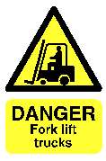

Yellow signs are warnings of particular hazards. Check with your supervisor before working in these areas.

HOUSEKEEPING


Everyone has a duty to keep their work areas tidy and free of potential slip, trip and fall hazards. Please report any concerns to your immediate Supervisor/Manager.

RISK ASSESSMENTS

A hazard is something that has the potential to cause harm, e.g. chemicals, electricity, using ladders etc.

The risk is the chance, however great or small, that someone will be harmed by the hazard.

There are five steps in the risk assessment process:-
- Identify the hazards.
- Decide who might be harmed and how.
- Evaluate the risks arising from the hazards and decide whether existing precautions are adequate or more should be done.
- Record your findings and inform those affected.
- Review your assessment regularly and revise it when necessary.

Risk Assessments are no good unless you, the worker / user, are fully aware of their content. They will tell you what risks are involved and the control measures you will need to have in place. This will then help you carry out your activity reducing the risks to yourselves and anyone else.

It is your responsibility to familiarise yourself with relevant risk assessments within your work area.

If you feel there is a significant risk that is not currently supported by a written risk assessment, please report this to your Manager or Supervisor.

Intervention Services Limited requires that a written risk assessment support any activity where a hazard is identified. There may also be specific issues regarding risk assessments for disabled staff in relation to the activity and further advice may be obtained from your Manager.

PPE (Responsibilities of the Employee and the Employer)
Personal Protective Equipment

Employer’s duties with regard to PPE.
- As per section 2 of the HASAWA 1974 (Heath And Safety At Work Act 1974) your Employer has a duty to provide suitable PPE to all Employees who may be exposed to a risk to their health and safety at work, except where the risk has been adequately controlled by other means which are equally or more. Effective.
- For PPE to be suitable it has to be appropriate for the risk(s) and conditions where exposure may occur.
- Take into account the ergonomic needs of the user.
- Fit the wearer correctly.
- Be effective in preventing or controlling the risk involved without increasing the overall risk.
- Ensure all PPE provided is CE marked to demonstrate compliance with relevant European standards.
- To provide workers with areas to safely store PPE When not in use
- To replace defective, missing PPE When required.
Workers Duties with regard to PPE
- All workers have Legal and operational responsibilities with regard to the safe use, maintenance and storage of PPE, as parsec 7 & 8 of the HASAWA Act 1974
- All PPE should be worn as indicated within the job specific risk assessments and as per toolbox talks and training. If you are unsure of how to use a piece of PPE then consult your Manager or Supervisor prior to starting work.
- All PPE should be stored safely in dry clean conditions when not in use in order to ensure it operates at maximum efficiency. Avoid contact with chemicals, sunlight, high humidity, heat and accidental knocks.
- Any lost or damaged PPE must be reported to your supervisor or manager immediately for replacements to be issued. If the PPE Is found to be of insufficient quality it must be reported immediately. (Remember some types of PPE have a shelf life and need to be replaced periodically)

Main types of PPE Available
- Head Protection:
- Crash Helmets
- Hard hats
- Bump Caps
- Hair nets

- Eye protection:
- Safety glasses (general protection against impacts)
- Safety Goggles (Provide a higher level of protection but can mist)
- Face shields (Protects whole face from chemical splashes etc. but offer little protection against fumes and dust)

- Body Protection:
- Trousers, Polo tops, Jackets, (protect against hot cold and wet conditions, proban or nomex treated garments protect against flashes and burns)
- Asbestos workers wear hooded overalls with elasticated sleeves, hood, cuffs and ankles to protect from exposure to asbestos fibres.

- Hand Arm protection:
- Gloves and gauntlets are available in a variety of types and safety ratings, examples include, nitrile rubber gloves, rigger gloves, Leather drivers gloves, Anti vibration gloves

- Foot protection:
- Safety boots, boots are required to have padded ankle support, reinforced steel sole and Steel toe cap.

- Respiratory Protective Equipment (RPE)
- There are broadly two types of RPE, respirators and breathing apparatus, respirators are those which work by filtering contaminants out of the air9 this can include simple dust masks) and breathing apparatus works by delivering a supply of fresh air from an uncontaminated source.
PORTABLE EQUIPMENT

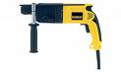
Intervention Services Limited makes regular inspections of electrical equipment to ensure that it is safe and fit to use. Each piece of equipment should have a label on it, which details the date that the equipment was last tested and the date when the next test is due. If an item does not have a label on it or is out of date, then it needs to be tested before you continue to use it.

If you bring in any electrical equipment to your work place e.g. radios, kettles, etc. you must get approval for the item to be tested before you use it. Any appliance found on site that has not been tested will be removed.

CONTRACTORS

Any staff responsible for organising the use of contractors on Intervention Services Limited premises / grounds must only select approved companies who are competent in their area.

All Contractors must receive a health and safety induction from the member of staff in charge of the work. There is a specific “Contractors Health and Safety Procedure”, copies of which can be found in the H&S Policy Manual maintained in the production office.

VISITORS

All visitors to Intervention Services Limited must report to the reception on arrival and required to sign in.
If you are responsible for any visitors to Intervention Services Limited then you must consider and ensure their personal safety taking into account any special requirements, such as language, disability etc.
Visitors must follow Intervention Services Limited safety procedures at all times.

USING DISPLAY SCREEN EQUIPMENT

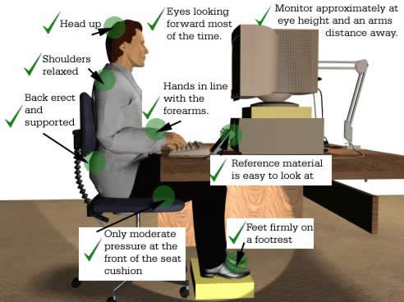

(DSE)

The majority of us now use computers whilst at work. There are specific legislative regulations, which cover the use of DSE. Intervention Services Limited has a detailed policy that can be found in the main H&S Policy Manual, but here are a few of the main guidelines that you should consider:

- You should not sit directly facing a window or with your back to a window. Ideally the DSE should be positioned at 90 degrees to the window.
- Your screen should be in front of you with the top of the equipment approximately level with your head.
- You should not twist your body in order to use the DSE, rather reposition the equipment or adjust your chair.
- When using the DSE your elbows should be at an angle of about 90 degrees to the keypad, with your wrists flat.
- When sitting, your legs should ideally be at 90 degrees and your feet should be flat on the floor. Your legs should not touch the top of your desk. Any problems, contact your QSE Manager for advice.
- Chairs should ideally have 5-pronged feet. This reduces the risk of toppling. All new chairs should have fully adjustable height, back support and seat tip. The majority of DSE problems are generated by not adjusting your seat properly.

If you share your desk, you should consider your comfort each time you use the DSE. After all, if you had to drive a strange car, you would assess your seating before driving off!

Remember these guidelines are NOT to be considered as an exhaustive list

For further information and advice on assessing and setting up your workstation, see the Intervention Services Limited’s DSE Policy.

MANUAL HANDLING


Some staff will be involved with manual handling as an everyday part of their job. In such cases, specific training will be given. For those who are not “normally” required to maneuver objects, you still need to consider manual handling issues. YOU must have assessed whether you are able to lift items in a safe manner BEFORE you undertake the task. A detailed manual handling policy can be found in the H&S Policy Manual but some general guidance follows:

- Has a risk assessment for the task already been completed?
- Do YOU really need to move it? Get help if required;
- Assess HOW you will move it and where to BEFORE undertaking the task;
- Always try to eliminate or reduce the load, undertake 2 trips rather than just one;
- Position your feet apart to get a stable base;
- Bend from your knees and not your back;
- Get a firm grip of the article;
- Keep the load close to the body – this means there is less impact on your spine;
- Lift the item in a smooth manner – do not jerk;
- Try not to move from the floor to “over shoulder height” in one move. Break the move up if possible.

To help you to remember what to do before lifting an object, remember the acronym T.I.L.E.

Task
Individual
Load
Environment

WORKING AT HEIGHT

Preventing falls from height requires sensible risk management, a principle that underpins the framework of Working at Height Regulations 2005 (WAHR) and all other health and safety legislation.

The WAHR set out a simple hierarchy for managing work at height and selecting equipment for use when carrying out work at height, namely:
- Avoid the need to work at height wherever possible
- Use appropriate equipment or take other steps to protect against falls where working at height cannot be avoided.
- Where possibility of a fall cannot be eliminated, use all means possible to minimise the distance and consequences of a fall should one occur.

Duty holders’ Responsibilities

The WAHR specifically require duty holders (employers, the self-employed and any person who may contract others to work at height) to ensure: -
- All work at height is properly planned and organised.
- All work at height takes account of weather conditions that could endanger health and safety.
- Those involved in work at height are trained and competent.
- The place where work at height is carried out is safe.
- Equipment used for work at height is appropriately inspected.
- The risks from fragile surfaces are properly controlled.
- The risks from falling objects are properly controlled.
- Ensure work is properly planned, appropriately supervised and carried out in as safe a way ‘as is reasonably practicable’.
- Plan for emergencies and rescue.
- Take account of the risk assessment carried out under Regulation 3 of the Management of Health and Safety at Work Regulations 1999.

Falling Objects

When working at height, you must do what is 'reasonably practicable' to prevent material/objects falling and take all 'reasonably practicable' steps to ensure that no one is injured by material/objects falling.
As a duty holder you must ensure: -

- That nothing is thrown or tipped from height if it is likely to injure anyone.
- That nothing is stored is such a way that its movement is likely to injure anyone.

COSHH

Intervention Services Limited are responsible, under the Control of Substances Hazardous to Health (COSHH) regulations, for ensuring that they and their Employees do not use substances in any form, e.g. solid, liquid, gas, fume or vapour, in a way that could cause harm to their own or other people’s health.

All substances used by Intervention Services Limited must be assessed before they are used. The purpose of the assessment is to identify the ways in which the use of substances can present risks to health, so that these risks are controlled to an acceptable level.

- Unattended hazardous materials must be locked away and lids/tops secured
- Materials safety data sheets and COSHH assessments are maintained in the production office.
- Emergency procedures to be followed are set out in data sheets and relevant risk assessments. All accidents, spillages etc. must be immediately reported to Management.
- Pumps and fluids being used or transported must be placed in plastic boxes or trays. Absorbent material must be available at all times.

- Fire extinguishers must be readily available in/near stores and the stores must be properly ventilated.
- Barrier cream, gloves, hand and face cleaning wipes and eyewash must be available.
- No smoking applies to all chemical storage or usage areas, including outside storage and warning notices must be displayed detailing hazards.

HAVS

Background

Vibration exposure from prolonged and regular work with power hand-held tools equipment or processes can have adverse effects on the hands and arms of users. Without effective controls, workers using such forms of equipment may suffer various forms of damage, collectively known as “hand-arm vibration syndrome” (HAVS). This is a painful condition and the effects can include impaired blood circulation, damage to the nerves and muscles, and loss of ability to grip properly. The best known form of damage is “vibration white finger” (VWF), which is a prescribed industrial disease.

How to Approach a Vibration Problem.

Any worker who uses powered hand-held or hand-guided tools as a major part of their job may be at risk of developing vibration injury to their hands and arms. Many workers who need to hold work-pieces in direct contact with machinery may face similar risks. In particular, any job that causes tingling or numbness in the finger, or where blanching occurs, should be regarded as suspect. For powered hand tools, it may be easier to assume there is a problem when there is regular and prolonged use. If you experience any of the above symptoms please inform management immediately.

ENVIRONMENTAL AWARENESS
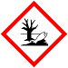
Although Intervention Services Limited is located within an Industrial Area there is a strong environmental policy, which commits Intervention Services Limited to the promotion of good environmental practice across all its activities and services.

CAR PARKING
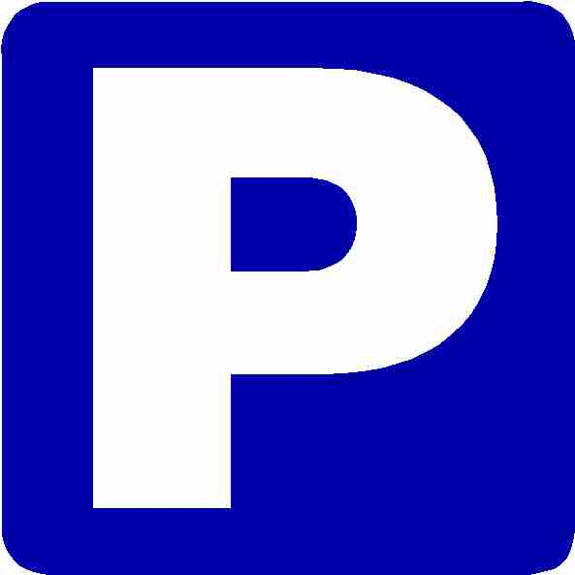
Intervention Services Limited cannot be responsible for workers vehicles outside of its immediate premises, and cars parked in Intervention Services Limited own car park are at the owner’s risk.

SMOKING
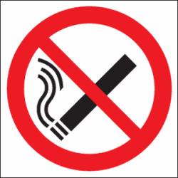
Smoking is prohibited in Intervention Services Limited buildings in accordance with current UK Law.
Smoking and the use of e-cigarettes is not permitted inside the building this is only allowed in the designated smoking area.

DRIVERS POLICY

MOBILE PHONES

Increasingly employees are using mobile phones as a necessary adjunct to their employment. The use of a mobile phones whilst on the move is considered to be a distracting to the point where safety may become impaired, therefore their use whilst driving a moving vehicle on Company business is forbidden. Current law forbids using a mobile phone for 'interactive communication' while driving. However the police can charge you for driving without due care and attention or careless driving. Driving without due care and attention will result in a fixed-penalty notice (FPN)

ALCOHOL and DRUGS
The company operates a zero tolerance on alcohol and drugs whilst on company property/business or in a company vehicle.
It is categorically forbidden for workers to drive a vehicle; whether on or off duty; in an unfit state due to the influence of alcohol or illegal drugs and other substances, such as glue; or to be in possession of illegal drugs on Company property/business or in a Company vehicle or in your own vehicle if it is being driven on Company business. Workers taking medicines or prescribed drugs under the direction of their G.P.’ Dentist, and Hospital Doctor must notify their immediate Line Manager.

HOURS OF DRIVING/WORK AND BREAKS

The Company requires that when driving long distances, a 15-minute break must be taken at least every 2 hours and sooner if the worker feels tired. It also requires that a total if no more that 11 hours maximum time be spent driving in a 24-hour period. The maximum time spent driving in a 24-hour period must be limited to 9 hours. (Drivers of commercial vehicles must follow their own regulations) If necessary, work routines must be re-planned or overnight stays arranged. Line managers must also ensure they do not issue work instructions that contravene these requirements. You are required by the Company to complete the daily/weekly drivers log and: -

- Return a copy on a weekly basis to your Manager.
- Keep a copy (in the vehicle) available for inspection.

SMOKING

Whether a driver or passenger, whether on or off duty, smoking is expressly forbidden in any Company vehicle at any time. The “no-smoking” ban also applies to individuals who drive or ride in a non-company vehicle whilst it is being used on Company business.

DRIVING LICENCES

It is expressly forbidden to drive vehicles on any Company activity unless your license is valid for that class or group of vehicles (1991 RTA – Sections 17 (1/2). In order for the Company to meet its legal obligations it operates a “permit to drive” process; this means that your driving capability will be assessed, and your driving license will be cross referenced (validated) by the DVLA before such a “permit” is issued. Both driving capability and DVLA license validation shall be subject to random and routine checks thereafter. A copy license will be held by the Company; who must be notified immediately upon receipt of any changes which affect the validity of your license e.g. convictions and/or disqualification and/or DVLA notifiable medical condition.

VEHICLE CHECKS

Your vehicle together with all parts affecting road safety must be well maintained and serviced in line with the manufacturer’s specified schedule. Note: you as the driver share those responsibilities with the Company. This means that you too could be prosecuted as well as the Company if you drive a defective vehicle.

Daily Vehicle Checks

At the beginning of each working day you are required to check the following:

Glass (Windscreen, lenses, reflectors)
Must be clean to ensure maximum visibility: with no cracks, holes or other damages.

Oil
Must be midway between minimum and maximum levels.

Water
Washers, coolant and other fluids (e.g. hydraulic) must be at the correct levels.

Electrics
All lights must be in full working order with clean and undamaged lenses.

Tyres
Check pressure (when cold) and depth of tread. Look for damage. Pressures should be optimized according to the vehicle’s load and in accordance with the

manufacturer’s handbook. Wheel alignment must be in accordance with the vehicle’s specification.

You are required by Law to complete the daily/weekly defect log and: -
You must record and report all defects immediately by completing the defect book and handing in the defect sheet in to your manager.
Return a copy on a weekly basis to your Manager (if Nil defects reported).
Keep a copy (in the vehicle) available for inspection.

NOTE: your Manager will also carry out the check routine specified for your particular vehicle and will record and report any defect found. This document together with details of any action taken will be sent to the Road Safety Management Committee and to the senior Management of the Company.

TRACKERS
All company vehicles have fitted with trackers meeting our Fleet Insurance procedures

ACCIDENT PROCEDURE
In the event of an accident:-

At the scene

- STOP

- Exchange details with the Third Party:-

- Name and address of any party involved

- Registration marks for all vehicles involved and nature of damage

- Request insurance details from parties involved

- Name and address of witnesses

- Number of any police officer present

- Details of width of road and road names, position of vehicles, speed, direction of travel, skid marks, position of traffic signs, traffic islands, turnings etc., in the area. Show these details in a sketch.

- Weather conditions and visibility.

- Ring your Manager/Office.

If in the event of an accident, you are unable to trace the owner of a vehicle or property, you must then report the accident to the police within 24 hours. Failure to report an accident is an offence.

Don’t admit liability or fault regarding your driving or the condition of the vehicle. No offers or promises should be made to the third parties without the prior consent of our insurer and without taking legal advice. The police should otherwise be given all reasonable assistance.

REPORTING THE ACCIDENT

You are required to notify your immediate Manager as soon as possible after the accident and in any event within 24 hours. In the event you receive any letters to your home address from the third party insurers, hand them and the envelopes to your Manager immediately. Do not enter into any correspondence without first checking with your Manager.

Complete all of the relevant documentation as soon as possible and definitely no later than 48 hours after the accident. These should be sent to you immediate Manager who will discuss the accident with you and add his comments to the form. These documents will then be countersigned by him and copies sent to the Road Safety Management Committee and to the Senior Management of the Company. NOTE: these documents form the basis of the investigation and will be used in the event of any disciplinary action.

ACCIDENT CLASSIFICATION

The purpose of the accident classification process is to analyze the circumstances of an accident in order to learn from the experience and apply these learning outcomes in a positive way for the benefit of all in order to prevent recurrence and/or repetition.

Legal liability does not influence the classification process; this is determined by whether or not; you were driving to prevent the accident. To operate this procedure in a consistent and impartial manner; the Company uses a standard set of questions which enables a conclusion to be reached about the circumstances. If the answer to any questions is “NO” then conclusion is reached that the individual concerned was not driving to prevent the accident – therefore the classification is “avoidable”.

DISCIPLINARY ACTION

Disciplinary action will be taken in every case where a worker driving/safety performance is persistently below standard and where other methods have not led to improved performance. In all cases where disciplinary action is taken; details will be sent to the Senior Executive of the Company; a copy will be placed on the employee’s personal file and will be included within the annual appraisal.

BREAKDOWN PROCEDURE

In the event of a breakdown including tyre and windscreen failure the following procedure must be followed:

- Telephone Fitter – 07985 663206

- Notify your immediate Manager of the breakdown and customer you are unable to meet.

- Ensure that the vehicle is parked safely and secure at all times.

- Notify your immediate Manager if help has not arrived within one hour.

- Notify your immediate Manager when the vehicle is roadworthy of if the repair time is going to be excessive.

TRAFFIC OFFENCES

All breaches of Highway Code are your responsibility and all fines for traffic and parking offences are payable by you.

The following must be reported to your immediate manager without delay:

- If you are charged by the policy or warned that charges may be brought against you.

- If you receive a summons or letter informing you that the policy are not taking further action.

- The result of any prosecution under Road Traffic against you.

INFORMATION AND WHERE TO FIND IT

Details of staff with specific responsibilities will be available in the H&S Policy Manual. See your department manager for details.

If you need to contact using the telephone, please ring Intervention Services Limited on 01443 238188 and ask for:

Mike Donohoe 07977155919 Director
Jason Combes 07917601703 Operations Manager
Martin James 07879550563 Yard Coordinator
Gareth Spure 07917236993 Supervisor
Nick Bennion 07918 459495 Supervisor Central
Chris Smith 07918 455131 Supervisor Central
Paul James 07919676562 Supervisor
Tom Watkins 07985 663206 Plant & Transport
Claire Sales 07747445501 Office Manager

Intervention Services Limited has numerous policies and safety guidance notes covering various aspects of Health & Safety.

Detailed health & safety information is available, specific to your individual area. Please check with your Manager.

There is a health & safety notice board within the building in which you work. The notice board will display up to date and relevant Health & Safety & environmental information, such as committee minutes.

Please take time to locate and read the information.

RETURN SHEET

Please return this sheet to your Supervisor or Manager upon completion:

I have read the company H&S handbook and understand its contents:

Name:
Department:
Clock Number:
Date:
Signature:

Notes/Suggestions for Improvement/Inclusions to handbook:

